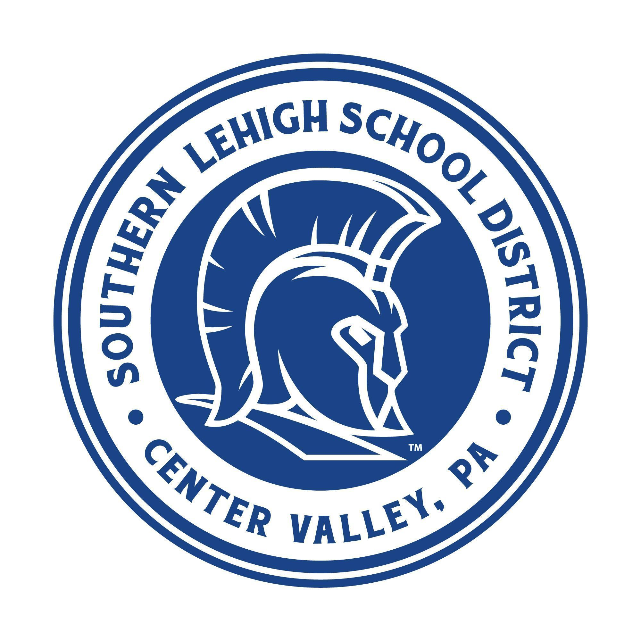

**SOUTHERN LEHIGH SCHOOL DISTRICT**

5775 MAIN STREET, CENTER VALLEY, PENNSYLVANIA 18034

Telephone: 610-282-1030   Fax: 610-282-2462

September 12, 2023

Dear Potential Sponsor:

“We invite you to support the Southern Lehigh School District by advertising on our digital scoreboard during home athletic events. Our district is known for its high-achieving students and its passionate community!”

– Dr. Michael Mahon, Superintendent of Schools

In order to assist you in considering this opportunity, we have attached our marketing brochure outlining the partnership packages available. Please keep in mind that the **Anchor Sponsorships** have already been filled by St. Luke’s, QNB Bank, The Inside Scoop, and Nature Valley Landscape.

**At this time we are still looking for Founding and Premier Partners as outlined below:**



Founding Partnership (6 Total) Premier Partnership (8 Total)

$2,500 per year – 5 Year Commitment $1,000 per year – 5 Year Commitment

Please see brochure for details Please see brochure for details

Reserve your spot by contacting our Business Administrator, Mr. Louis Pepe at 610-282-1030 ext. 5201 to complete the partnership agreement. Remaining partnerships are limited so do not miss out on this exciting opportunity!